CENTENNIAL COLLEGE
Information and Communication
Engineering Technology (ICET) DEPARTMENT
MID TERM EXAMINATION
SEMESTER: Summer 2025
Version 2

SUBJECT NAME: Advanced Database Concepts

SUBJECT CODE: COMP214 - Lab/Hands on

EXAMINATION DATE: Winter 2025

INSTRUCTOR NAME: ERSAN CAM

MARKS ALLOTTED: 60 out of 100
WEIGHTING:

Instructions:

- Add your name on this Word File when you are submitting.

- Always include copy paste version of your code and as well as Screen shot of code execution.
- * To detect Plagiarism, instructor has all the rights to use some applications (TurnItIn). If any cloned&copied work among classmates is being detected then students that they involved are subject to Centennial College’s Code of Academic Conduct document located below.
- * Please refer respected note about Plagiarism and Academic integrity from our Course Outline
https://library.centennialcollege.ca/help-services/research-help/academic-integrity/

Question 1 (20 Point)
- Explain each question below with your own words as minimum 2 lines of sentences

- What is the purpose of using loops in Oracle PL/SQL?
- Explain the basic syntax of a FOR loop in PL/SQL.
- How does a WHILE loop differ from a FOR loop in PL/SQL? Provide an example for each.
- What is the EXIT statement, and how is it used within a loop?
- Discuss the advantages and disadvantages of using the EXIT WHEN statement in loops.
- Explain the concept of nested loops in PL/SQL. Provide an example.
- How can you prevent an infinite loop in PL/SQL?
- What is the CONTINUE statement, and how is it used in PL/SQL loops?
- Compare and contrast the FOR loop and the LOOP...EXIT WHEN loop structures in PL/SQL.
- Explain the use of the CONTINUE WHEN statement in a PL/SQL loop.
1. The purpose of using loops in Oracle PL/SQL is to repeatedly do some action over some number of times. For example, to check if a condition has been met or to complete an arithmetic calculation.

2. The FOR keyword starts the loop. We assign a variable to some sort of range like so: i in lowerBound..upperBound which i will be assigned to the numeric value of the range upon each iteration. We must use the LOOP keyword before putting any executable lines in the FOR loop’s code block. We can put anything in the loop as long as it is valid and finally, to end the loop, we write END LOOP. In this example, i variable can be used, but only in the loop.

3. A WHILE loop is different than a FOR loop as a WHILE loop will go until some condition is met that can be determined at any time during the loop. A variable that the WHILE loop’s termination is based on can be changed during the loop’s execution. A FOR loop has a variable with a determined range as the variable can not be reassigned during the loop.
WHILE loop example
DECLARE
v_counter NUMBER := 1;
BEGIN
WHILE v_counter <= 13 LOOP
v_counter := v_counter + 1;
-- IF v_counter = 5 THEN v_counter := 12;
END LOOP;
END;
The while loop will go until v_counter is 13. BUT I can modify the v_counter variable (if I uncomment the 6th line) and the WHILE loop will run until it becomes 5 and then once more since v_counter will be 12 for the subsequent iteration. (v_counter will be 1 at start, then in the loop (first iteration) 2, 3, 4, 5 -> 12, 13)

FOR loop example
BEGIN
FOR i in 1..13 LOOP
DBMS_OUTPUT.PUT_LINE(i);
-- i := 564;
END LOOP;
END;
In the FOR loop example, the value of i is printed out. i will go from 1 to 13, incrementing by one each time.
Since we cannot change i’s value, if I uncommented the 4th line, we would get an error. The loop will run 13 times unless we used EXIT.

5.The EXIT statement is a statement that can be used to terminate the loop and return to the outer block. We can do an unconditional EXIT by just writing EXIT; or a conditional EXIT by writing EXIT WHEN <condition>. We can also EXIT <label> and EXIT <label> WHEN <condition> if we want to exit specific loops, such as outer loops when the code that is executing is in an inner loop.

6. The advantages of EXIT WHEN are that it can be used anywhere in a loop, is more concise than IF THEN ELSE statements, and is good for basic loops as a basic loop is infinite by default. The disadvantages are that, when it is used multiple times in a loop, it can be hard to keep track of what condition was met and where it exited, so readability and maintainability could suffer as a result of overuse.

7.Have conditions that would be met and exiting the loop with EXIT WHEN or wrapping an EXIT statement inside an IF statement. A FOR loop provides inherent protection from infinite loops as the range it iterates through will finish even if there are no EXIT statements.

8. The CONTINUE statement skips the rest of the statements in the loop’s iteration. It can be used in loops by writing CONTINUE; or CONTINUE WHEN <condition>;.

9. The FOR loop has iterations in a determined range and automatically exits when the range’s upper bound is reached. The LOOP… EXIT WHEN structure can allow for more complex loops, but requires proper usage of EXIT WHEN to prevent infinite loops. LOOP…EXIT WHEN structures allow for more complex loops by not having a set range, meaning the condition that would exit the loop could be anything. The FOR loop can exit whenever as well, but will, for sure, exit once the iteration is the upper bound.

10. CONTINUE WHEN is CONTINUE but with the addition of checking a condition for the CONTINUE to run. CONTINUE WHEN <condition>. This means the rest of the iteration will skip the rest of the loop’s iteration only when the condition is met.
b)

Develop a PL/SQL program that generates the following pattern using nested loops:
1
22
333
4444
55555

DECLARE
v_string VARCHAR(15);
BEGIN
FOR i in 1..5 LOOP
v_string := '';
FOR j in 1..i LOOP
v_string := v_string || i || ' ';
END LOOP;
DBMS_OUTPUT.PUT_LINE(v_string);
END LOOP;
END;

I declared a variable v_string to hold the value of each line.
Created 2 loops, Outer loop starts at 1 and ends at 5. Inner loop starts at 1 and ends at the current value of i.
I reset the value of v_string at the start of each iteration of the outer loop and output the line of v_string at the end of each iteration. In the middle, is my inner loop which concatenates v_string to itself in addition to the current value of i and a space.

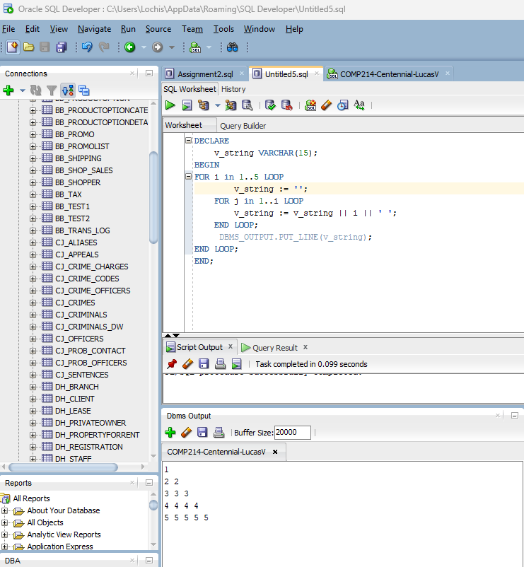

Question 2 (20 Point)

Ask end user to enter one number from 1 to 50

- If a number is less than 20
then check again
-- if this number is greater or equal to 10 then print
dbms_output.put_line('NUMBER IS IN BETWEEN 10 TO 19');
-- otherwise print
dbms_output.put_line('NUMBER IS LESS THAN OR EQUALS TO 9');

-Otherwise if number is not less than 20 (greater than 20)
check again
-- if number is greater or equal to 20 but less than 50 then
print dbms_output.put_line('NUMBER IS IN BETWEEN 20 TO 49');
-- otherwise print dbms_output.put_line('NUMBER IS GREATER THAN OR EQUALS TO 50');
Finish Control mechanism

DECLARE
v_num NUMBER := &one_to_fifty;
BEGIN
IF v_num < 20 THEN
IF v_num >= 10 THEN
DBMS_OUTPUT.PUT_LINE('NUMBER IS IN BETWEEN 10 TO 19');
ELSE
DBMS_OUTPUT.PUT_LINE('NUMBER IS LESS THAN OR EQUALS TO 9');
END IF;
ELSIF v_num > 20 THEN
IF v_num >= 20 AND v_num < 50 THEN
DBMS_OUTPUT.PUT_LINE('NUMBER IS IN BETWEEN 20 TO 49');
ELSE
DBMS_OUTPUT.PUT_LINE('NUMBER IS GREATER THAN OR EQUALS TO 50');
END IF;
END IF;
END;

I used IF ELSIF ELSE statements (3, two nested in one) to complete this question. I could have used a CASE v_num < 20 THEN instead of any of the IF statement’s, but I prefer to use IF statements. The program works as outlined, but in the ELSIF v_num > 20 THEN block, we have an IF statement that checks the condition of v_num >= 20 which can resolve to true, but the value of 20 will never print anything out since the ELSE IF v_num > 20 is checking only for values greater than 20.
In the screenshot (below) I entered: 1, 10, 20 (no output), 21, and then 102.
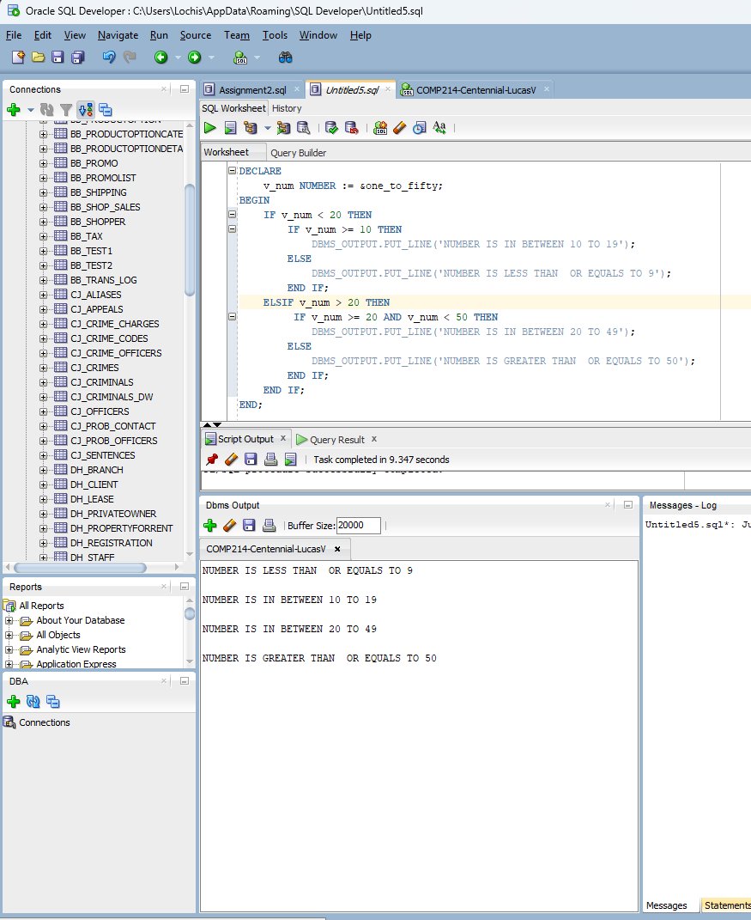

Question 3 : IF Statements (20 Points)
Brewbean’s (BB_XXX database) calculates shipping cost based on the quantity of items in an order. Assume the
quantity column in the BB_BASKET table contains the total number of items in a basket.
A PL/SQL block is needed to check the quantity provided by an initialized variable and determine the
shipping cost.
Display the calculated shipping cost onscreen.

Test using the basket IDs 5 and then do another test with basketID 12, and apply the shipping rates listed in below chart

Quantity of Items | Shipping Cost
Up to 6 | $8
7-9 | $10
10-12 | $12
More than 12 | $14

Hint: Provide User prompt with & and get the user entry for basket number
Then use this in WHERE condition
WHERE idBasket = &v_basket;
Use this SQL
SELECT quantity
INTO lv_qty_num
FROM bb_basket
WHERE idBasket = XXXXXX;

Explain your reasining and each line of your code

DECLARE
lv_qty_num NUMBER;
v_shipping_cost NUMBER;
BEGIN
SELECT quantity INTO lv_qty_num FROM bb_basket WHERE idBasket = &v_basket;
CASE
WHEN lv_qty_num BETWEEN 0 AND 6 THEN v_shipping_cost := 8;
WHEN lv_qty_num BETWEEN 7 AND 9 THEN v_shipping_cost := 10;
WHEN lv_qty_num BETWEEN 10 AND 12 THEN v_shipping_cost := 12;
WHEN lv_qty_num > 12 THEN v_shipping_cost := 14;
END CASE;

DBMS_OUTPUT.PUT_LINE('Shipping Cost: ' || v_shipping_cost);

END;

Line by line explanation:
- DECLARE keyword to start the declaration block
- Declared lv_qty_num so that the SELECT statement’s quantity can go into it and quantity is a number so I gave it the NUMBER data type.
- Decalred v_shipping_cost so that I can assign it based on the CASE expression that is true and it is a number so I gave it the NUMBER data type.
- BEGIN keyword to start the execution block.
- SELECT statement that assigns the result of quantity to lv_qty_num from the table bb_basket where the idBasket is equal to the input that the user enters.
- CASE keyword to start the CASE structure
- When lv_qty_num is between 0 and 6, v_shipping_cost will be assigned to 8
- When lv_qty_num is between 7 and 9, v_shipping_cost will be assigned to 10
- When lv_qty_num is between 10 and 12, v_shipping_cost will be assigned to 12
- When lv_qty_num is greater than 12, v_shipping_cost will be assigned to 14
- End the case structure with END CASE;
- –
- Output’s the shipping cost based on the value of lv_qty_num which is the quantity of the row in bb_basket when idBasket is equal to the inputted value by the user.
- –
- END; is used to end the execution block.

I used a CASE structure here because I used an IF statement structure in the previous question. No other reason as they both can provide the same functionality.
I concatenate Shipping Cost: with the v_shipping_cost variable to be clear in the output.

